THE NATO CHESS CHAMPIONSHIPS
A REVIEW OF THE LAST 25 YEARS

Personal memories of Alec Toll (UK),
with acknowledgement to Wolfgang Berger (GER)
*
It may surprise a few people to learn that the tournament was conceived over two decades ago by an Englishman - Ken Moore. Whilst working as a Forces Liaison Officer for the Danish Tourist Board back in 1978, Ken came up with a bright idea. He invited chess-players from the British Army on the Rhine (BAOR) and Germany’s Armed Forces to participate in a team chess tournament in Northern Denmark.

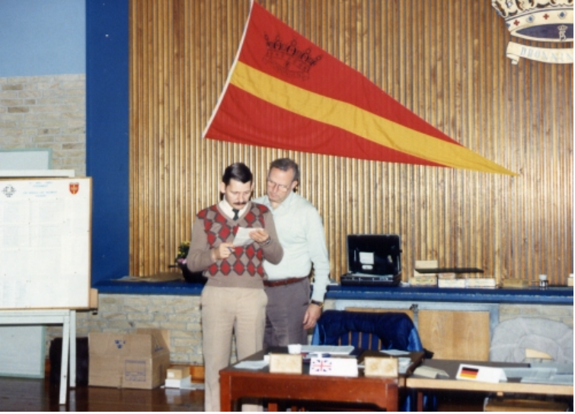

Excell and Berger compare notes at Aalborg in ‘83

He contacted a Staff Sergeant John Excell of BAOR, an active organiser and player in the Army Chess Association. Ken’s ally in Germany was a civilian working for the Armed Forces’ welfare, and a National Arbiter of the Deutsche Schach Bund, (German Chess Federation) - Mr. Wolfgang Berger. The stage was set for an incredible evolution…
*
From 9 - 13 October 1978, the very first event was staged at Norre-Uttrup Kaserne, Norresundby - a Danish Army barracks situated to the north of the city of Aalborg
a venue with which we were to become very familiar!

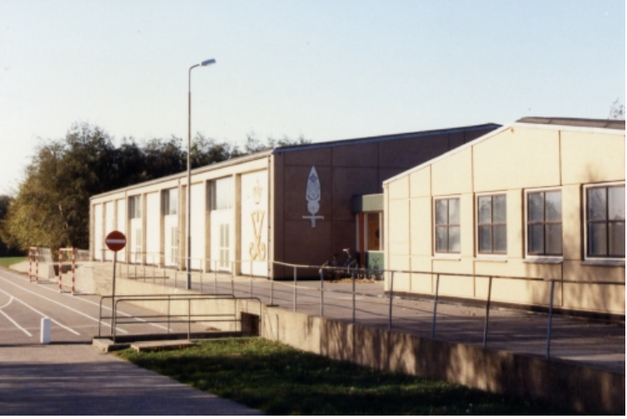
The gymnasium, venue of many Aalborg tournaments

Only four nations competed - 10 Danes, 9 Germans, 7 Americans and 12 Britons (all from BAOR) in a 10-board all-play-all team event of three rounds. Two Britons and a Dane played for the American side to balance up the numbers. In a foretaste of what was to follow, the Germans won all three of their encounters, whilst the Brits were second, defeating the Danes and Americans. The hosts managed a draw with the Americans, but finished third with 11.5 game points to the Yanks’ 11. Only two players, Andreasen (DK) and Erdmann (GER) managed 3/3. Equal third were Tomes and Morgan (both UK) on 2.5. A Blitz Tournament, attended by 27 players, was won by Burchardt ahead of Munst (both Germany). The Aalborg Tourist Association presented the winners with the Challenge Team Cup, which would also be competed for in the 1979 and 1980 events.
*
The following year saw the 1979 event switched to the nearby Aalborg airbase, with Germany once again crushing all resistance, 7 of their players scoring 100%! In 1980, also at the airbase, Germany entered two teams, which came first and second. An extra round was necessary to accommodate the increased number of sides. This was to be the last of the purely ‘team’ events, as the outcome had become rather predictable.
*
In 1981, back at the Aalborg barracks, a new format was conceived, which was to prove so successful as to continue more or less unchanged to the present day. The players competed in a 7-round Swiss event, with the best five players’ scores counting towards their nation’s team total. (Nowadays, it is only the top four that count.) Two new teams participated, Canada (2 players) and Norway (6).

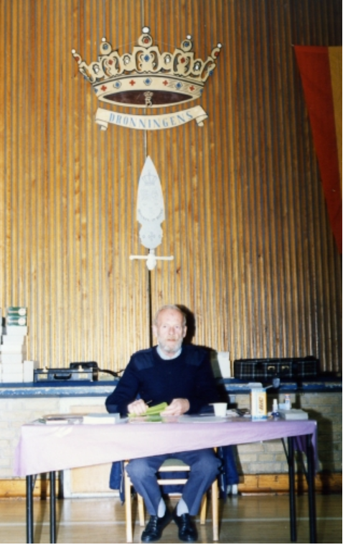

Otto von Ibendfeldt – arbiter in Aalborg

Inevitably, the all-conquering German team made it four wins in four events, with 27.5 points from a possible 35. Egger (WG) won the individual event with 6/7, followed by no less than six of his team-mates. Liabotro (NOR) with 5/7 prevented a clean sweep. On their first showing, the Norwegian team managed second place, with UK a dismal 5th, ahead of the two Canadians.
*
1982 was the year of the Falklands War. With Britain’s Armed Forces gainfully employed in the South Atlantic, the conflict and it’s aftermath ensured that there would be no Combined Services Championship back in UK, with the Army due to host it. The RAF match captain in those days was Sgt Danny O’Byrne. He received a communique from the recently-promoted Warrant Officer Excell, inviting RAF players to strengthen the UK team in Denmark. Danny agreed, and assembled a team which included Cpl John Treasurer - the reigning Forces’ champion, Cpl Geoff Sage and SAC Alec Toll. Excell had already selected 4 BAOR soldiers and a NAAFI manager, so a large team of 12 made their way to the Queen’s Life Regiment Barracks at the usual venue in Aalborg to take on the might of the Germans.

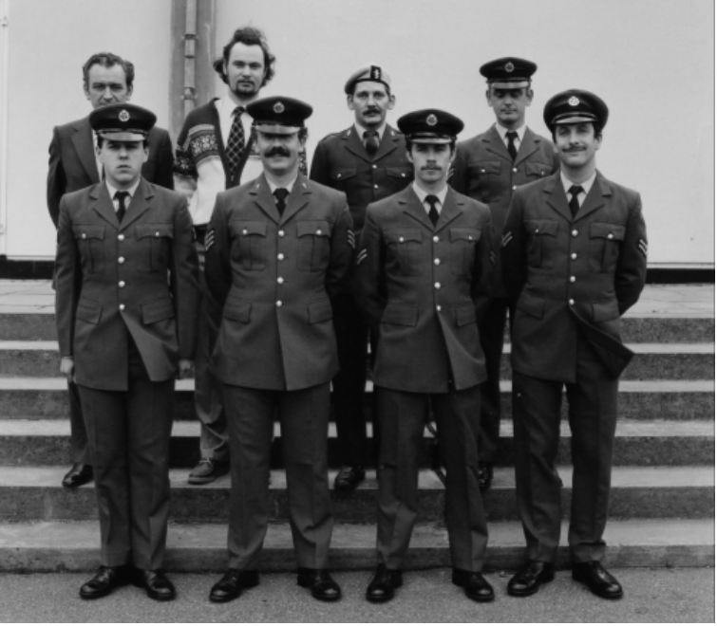

UK team photo – Aalborg’82

John and Geoff both scored 4/7, and the UK made a team score of 18.5/35. This wasn’t enough to worry the Germans though, as they scooped victory number 5 with 27.5 points, ahead of America (23) and Norway (21.5). The RAF lads all thoroughly enjoyed the experience, especially the amazing Aalborg nightlife and Danish ferry trip, and were to be ever-present in future years. Major Don Nolte (US Army) produced a lengthy set of rules specific to the NATO events, designed to smooth increasingly troubled waters but this only lead to further disagreement amongst team leaders.
*
By 1983, the event had turned into a two-horse race between the improving Norwegians and the mega-strong Germans. Unsurprisingly, the latter triumphed once again, with future Grandmaster Gerald Hertneck cruising home with 7/7- the first real 100% score in the NATO.

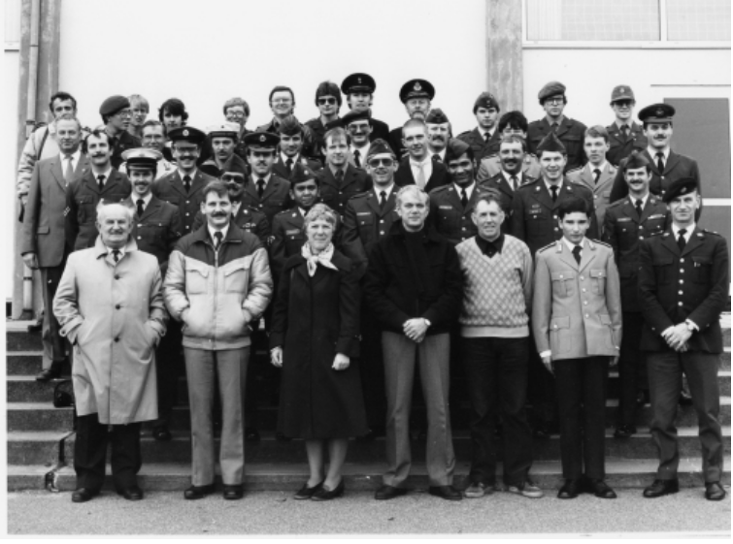

Group photo – Alborg ‘83

Language barriers, coupled with subtle differences in individual countries’ interpretations of FIDE rules often led to similar confrontations. Such moments were commonplace in the early tournaments. It is refreshing and pleasing to see how genuine sportsmanship prevails these days.
*
In 1984, the UK-based element of the team failed to appear, and an extremely weak side from BAOR and the RAF bases in Germany took a pounding. I was fortunate to be stationed at RAF Gutersloh in Germany at the time and was selected to play, managing just three draws and four losses. Even so, this was enough to make me ‘top Brit’ - for which I was presented with a fine trophy! In seven rounds the entire UK team failed to win a single game. Matuttis (WG) made 6/7 despite being the 18th seed.
*

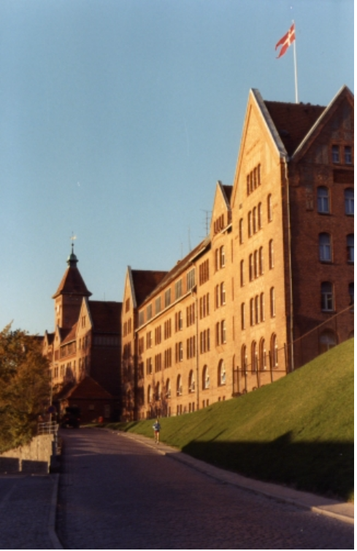

Sonderborg Barracks ‘85

In 1985, the venue was switched to the picturesque port of Sonderborg in the south of Denmark, just over the border from Germany. Held in the NCO’s school in a fine historic building, this was a class above the drab, troop-beaten Aalborg barracks. The only snag was that Combat Training continued around us - during play, NCOs could be detected crawling through the long grass fully camouflaged! In my best blue uniform, peaked cap and displaying a Senior Aircraftsman’s three-propeller badge on my arm, I was mistaken for a helicopter pilot, and saluted on several occasions by wary troops! John Treasurer produced a wonderful performance - scoring 4.5/7, which included a disappointing final-round loss after several brilliant victories.
*
In 1986 back in Aalborg, the Belgians made their first appearance. The tournament was controlled by RAF stalwart Sqn Ldr Chas Fox – shortly to retire from the Service. Each nation entered two teams of four players, For the first time, UK included a representative from the Royal Navy in the person of Lieutenant Commander Laurie Brokenshire (channel-swimmer and magician!).
UK1 sensationally led the event after three rounds, but the German machine cruised past in round 4, unstoppably so. Arthur Brameld caused a 1st round sensation, drawing with the Norwegian IGM Agdestein in a well-prepared line of the King’s Gambit, but the Master won the next six, and the individual title. Remarkably, the lowest rated player - Store (Norway) came second, belying his grade, but as a team, we had learned not to trust these highly unreliable statistics.
*
A magnificent trophy - a marvellous Viking ship had been presented to the winning team in 1981 - sponsored by Danish brewers Tuborg. Germany hoisted it every year from ‘81 to ‘88 with the sole exception of 1987. For once, a slip in their normally disciplined performance lead directly to the team’s first failure at the NATO, conceding first place to a Norwegian side once again boasting the talents of International Grandmaster Simen Agdestein - at that time in the world’s top 20! The Norwegians and Germans dominated the event, with their conscript-filled teams parading much higher Elo ratings than the other nations’ competitors.
*
The 11th annual event (1988) proved to be a turning point in the tournament’s history - but not for happenings in the tournament hall. Disgruntled teams containing very senior officers were housed together in rough army transit accommodation. The inclusion of highly-rated players requiring professional standards of chess organisation led to a stormy meeting of team officials. Ken Moore was faced with an almost impossible ultimatum - improve conditions, or Denmark would lose control of the prestigious NATO Championships. The idea of rotating the event around all the participating NATO countries was mooted, to overwhelming support. Ken promised to investigate the possibility of hosting the 1989 event in the Danish capital - Copenhagen, which met with a great deal of approval. In truth, the event had become too big for both Ken and the Danes to handle. Ken’s ‘baby’ had simply out-grown him. A great shame, though speaking to him recently (he lives just 5 miles away from me in Norfolk!) I believe he has come to accept it as a natural progression.

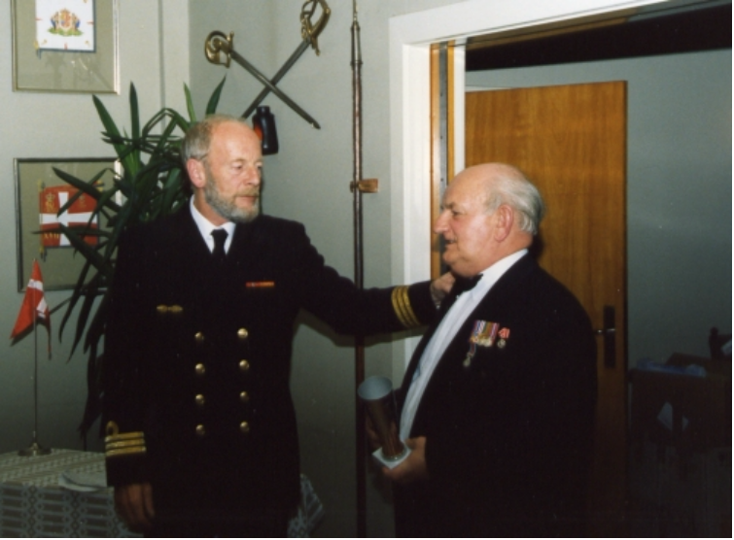
Otto makes a thank-you presentation to Ken Moore, Officer’s Mess Aalborg

Away from the political machinations, the Germans were doing very nicely. With two FMs and an IM in their side, it was an untitled player - Gallinis who hit top form with 6.5/7. The Brits managed a satisfactory 5th place (out of 11 teams) with Sage, Toll, Watson and Crockart scoring, but Treasurer got badly bruised - bouncing off ‘the German Wall’, finishing on 3/7 after starting with 2/3. Playing his first NATO, and suffering badly, was an SAC Andy Hammond, who finished 40th with a win, two draws and four consecutive defeats - the learning curve had begun!
*

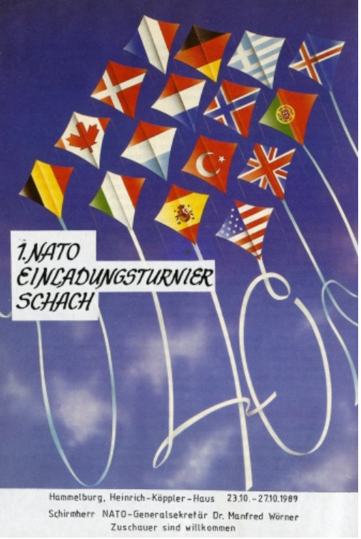

Official poster – Hammelburg ‘89

With quite literally a tremendous fanfare, the NATO headed kicking and screaming towards a new beginning. When in 1989 Ken was unable to provide a venue in Copenhagen, once again offering Aalborg, the member countries went their own way, and the Germans hosted a fantastic event in Hammelburg. For the first time, the tournament was given the full official support of NATO. Modestly re-titled the 1st NATO Team Chess Championships, the hosts pulled off an incredible coup, the prizes presented by the charismatic Secretary-General of NATO, Dr Manfred Worner. The whole week was co-ordinated and organised to perfection, with nothing left to chance. Competitors were ferried around by an ever-available fleet of hire cars, with a huge staff beavering away behind-the-scenes.

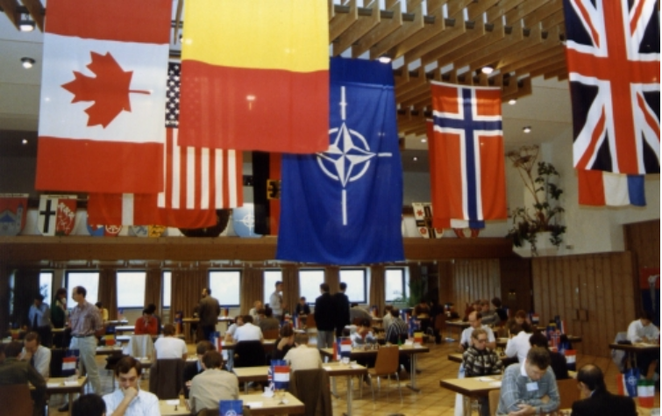

The flag-adorned tournament hall - Hammelburg

It was a memorable championship, which set the other countries a tough act to follow. Perhaps even more memorably, a visit to the nearby West/East Germany border was put into perspective only a few weeks later when the Berlin Wall came down. Now the German team would be even stronger!!
The list of participating countries had expanded, to include Holland, France, Italy and Luxembourg, with a record number of 72 players taking part. The tournament was skillfully directed by the successful pairing of the ubiquitous Wolfgang Berger and the aristocratic Commander Otto Graf von Ibenfeldt (Norwegian Navy). The hosts stormed away with the prizes leaving in their wake six countries vying for the runners-up slot, surprisingly claimed by the USA.

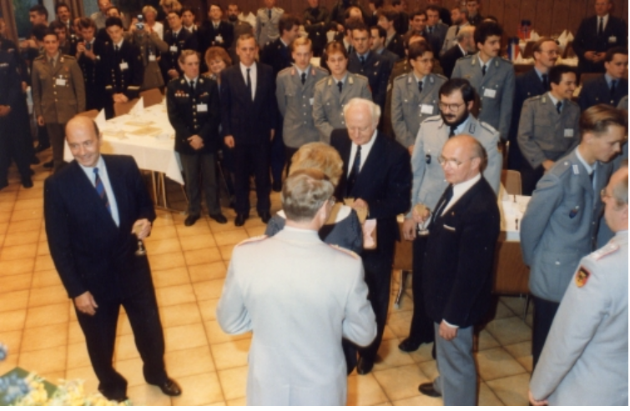

Manfred Worner (left) presents the trophies at Hammelburg

Staff Sgt George Crockart was best Brit, though I too scored 4.5 points, having 3 in the bag after 4 rounds. Andy Hammond kept up his personal standard, once again finishing 40th. A new trophy - a gleaming bronze cup, was donated by the German Catholic Work-Group for Soldiers. At the final banquet, Otto announced that the 2nd Official NATO would be held in Oslo in 1990. The ‘NATO’ had really hit the big time!........
*
Off to Norway, land of Vikings, fish-eaters, extremely expensive beer and petrol. With the NATO going ‘up-market’, the Opening Ceremony of the 2nd NATO Championship was a fine example of Euro One-Upmanship. Whilst the Germans had opened the Hammelburg event with a noisy military band, the Norwegians opted for a rather more cultured approach, a much-feted local soloist belting out songs from the popular musical ‘Chess’. Situated slap-bang in Oslo city square, the week was notable for a cracking tournament, a ‘super-loo’ with a super view, and a visit to a local park with highly pornographic statues! The farewell dinner featured traditional folk-dancing, and an exquisite menu which included reindeer steak. Germany once again scooped the honours, but only on tie-break from their hosts. FM Deleyn (BEL) was best overall player, and I was presented with an incredibly heavy lead-crystal polar bear statuette, pipping Andy Hammond to ‘best Brit’, much to his annoyance. Wing Commander Bob Kermeen in his team speech invited the other nations to the 3rd NATO, which was to be held at RAF College Cranwell, Lincolnshire in 1991.....
*

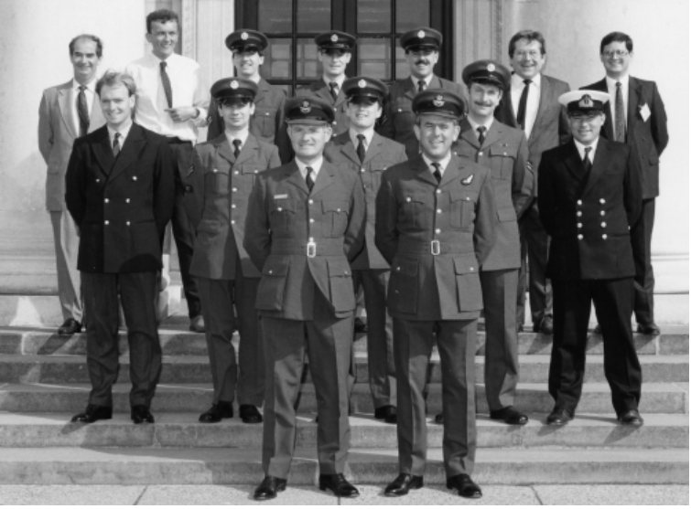

UK Team and organising officials – Cranwell ‘91

With the two Wing Commanders Bob Kermeen and Paul Watson busy organising the 3rd NATO event, a weakened UK side enlisted the help of International Master Andrew Martin as team coach - and promptly finished last! The converted gymnasium made a fine venue, festooned with the national flags of the competing nations. A 5-a-side football competition provided a welcome break from the chess, though an enforced substitution for the injured Hammond saw the youthful Watson take on the centre-forward mantle!

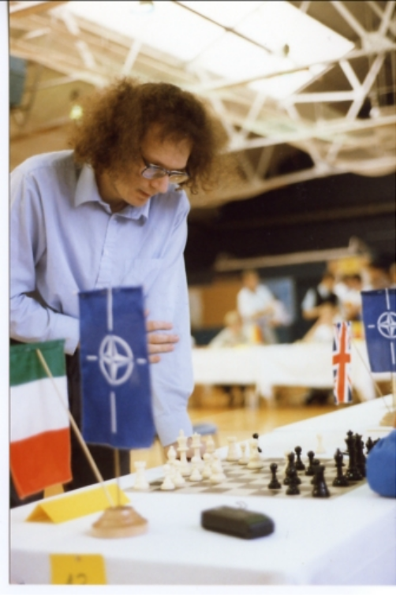

Speelman’s simultaneous, Cranwell

IGM Jonathan Speelman gave an excellent Simultaneous Display, but found the allied powers a tough prospect, and finished with a score of 19-7, totally exhausted!
Once again, the Germans proved their worth, Lucke taking the honours with 6.5/7 and Arthur Brameld was Best Brit with 4/7. A memorable NATO, excellently managed by Bob and Paul, with their guests introduced to such British delights as Guinness and filled Yorkshire puddings!
Notably, the 1991 event saw the formation of an International Military Chess Committee, responsible for forward planning and ensuring the future of the event. Spearheaded by it’s Chairman - Brigadier General Steffers of the Dutch Army, many of the ‘loose ends’ were tied up, and a clear direction out-lined.
*
Andy Martin again accompanied the team to Munster-Handorf, Germany in 1992 for the 4th NATO. The Danes reappeared for the first time since being snubbed in 1989, as did a sole Luxembourgian. Surprisingly, UK’s Captain Gordon Stables emerged as the in-form Brit, scoring 4 points. Deutschland dominated once more, Carsten Lingnau accumulating 6/7. It was important for the continuation of the event that Germany had stepped in at the last minute to organise the event, with Italy requesting more time to arrange the competition.

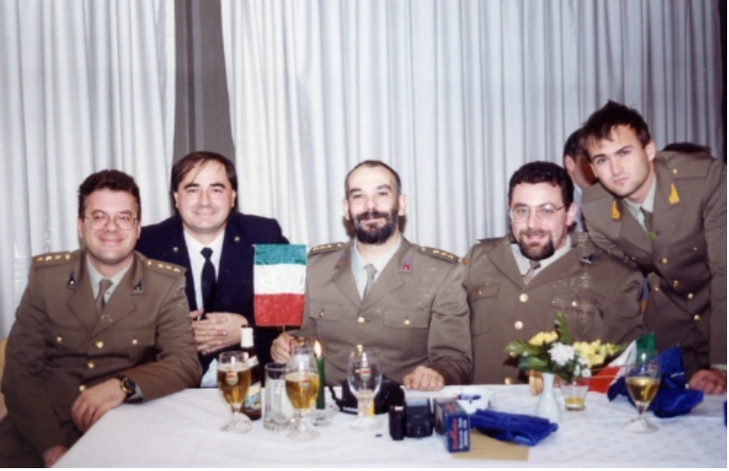

Italian team at the banquet, Munster ‘92

*
Similarly, the 1993 event was cursed by organisational problems and was not included in the canon of ‘Official’ NATO Championships. The Americans had pledged to run it, but it was left to the Dutch, who were already in the frame for the following year. It was held in probably the most spectacular and historic venue to date - the 12th century Royal Military Academy, a turretted and moated castle in the centre of the town of Breda. The format had to be changed due to the hurried schedule, so six 5-man teams did battle in five head-to-head encounters in Olympiad style.

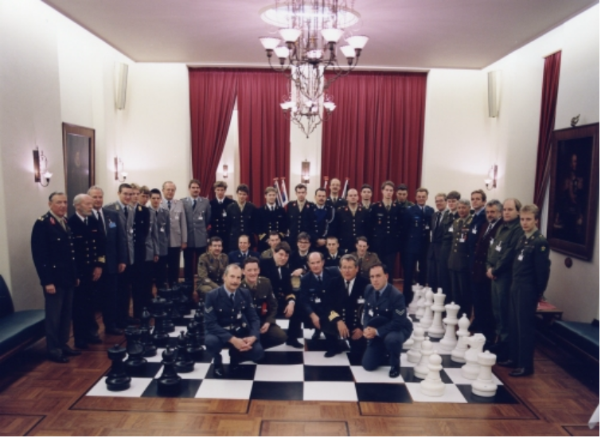

The unofficial tournament – Breda ‘93

The protracted opening ceremony involved an unusual method of choosing colours for the first round, which proved almost as complex as the game itself! Andy Hammond was absent for the second successive year, his place filled by Sgt Neil McInnes, a NATO regular over the years. Lt Cdr Paul Kemp (RN) was suffering from back pains, and opted to play for an inaugural NATO team -made up of spare players from each team - but ended up out-scoring all the Brits with 3.5/5. Norway almost stole it, but the Germans won by one point. UK managed a draw with the Belgians and defeated the NATO team. For the first time, round-by-round bulletins arrived at our breakfast tables, necessitating long nights of hard work for the editor and his team!
*
On returning to Breda in 1994 for the 5th NATO, the venue had changed slightly to the Officer’s Training Centre in the nearby Seelig Barracks. As part of what was an immaculately-run event, the Dutch laid a giant chess patio set outside the playing hall, leading to many ridiculous late-night games being played out by returning drunkards, to the amusement of the frozen guards. Underlining the meticulous preparation, the daily menu was themed after a different country’s specialities. UK was mercifully spared the ignominy of offering ‘fish and chips’ served out of a newspaper! Sgt Andy Foulds & Cpl Neil Clifford (RAF), Lt Scott Bower (RN) and Major Andy Parrott (Army) made their debuts along with some familiar British faces.

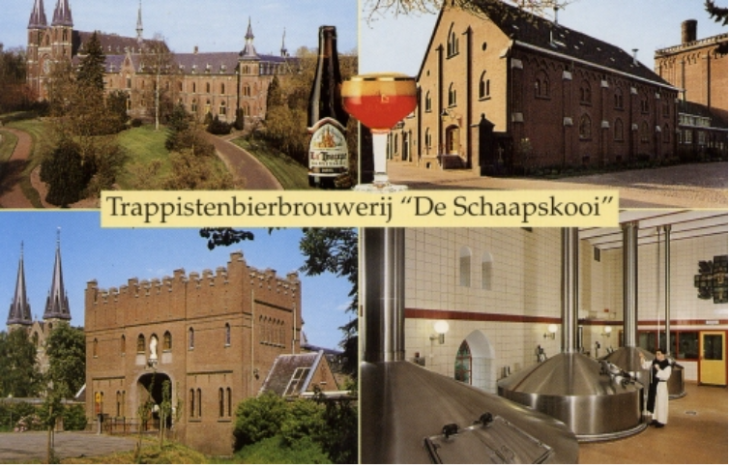

The Trappist monks’ brewery!

A visit to a Trappist monastery provided an unforgettable NATO memory, with the assembled players exposed to the monks’ special quadruple-strength winter ale, with predictably hilarious results. A cliff-hanging final round saw the Brits in with an outside chance of actually lifting the trophy, but as usual, the previous evening’s excesses scuppered our chances. Norway emerged victorious, a mere two points ahead of UK in fifth. Arthur Brameld took the individual kudos with 5/7. Spoom (at the table) was on the final banquet menu, leading to Geoff Sage developing the unplayable Spoom Gambit, (1.Nf3 g5!) which he is still working on to this day!
*
Gausdal! Home of many a strong International Chess Tournament in years gone by. The picturesque High-Mountain Hotel ski resort was cloaked in an icy, snowflake-covered fairy-tale winter wonderland when we finally arrived in Norway for the 6th NATO in 1995 - by planes, trains and automobiles! Situated several kilometres north of Lillehammer, the various teams were spoiled rotten and treated like royalty.

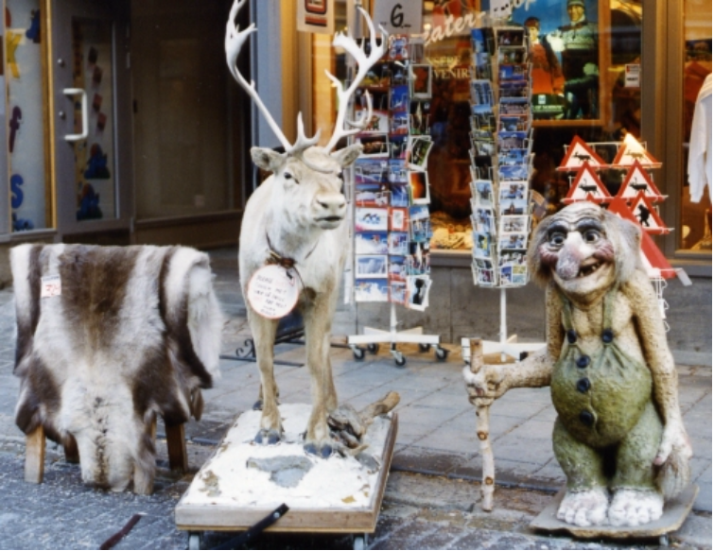

Norwegian icons in the High Street, Lillehammer

We were taken on a guided tour around the town, which hosted the 1994 Winter Olympics, and were treated to a wonderful concert at the Town Hall. Sqn Ldr Miles Patterson made his final appearance, before transferring to the Australian Air Force, and rookie L/Cpl Tony Aspin defied the odds by street-fighting his way to four wins and a draw, and 11th place. There was to be a new name on the trophy - Holland and deservedly so, outpacing Germany and Norway to surprise the knowledgeable pundits. Jonkman (Dutch Army) strolled to 6.5/7, completing the temporary removal of the Germans’ trophies. At the final banquet, there were no reindeer steaks, but plenty of herring, salmon, trout, codfish, crab, grouse, moose, pork and mutton, which made for a wonderful spread, consumed before the traditional speeches. The evening’s performance by a local traditional folk-dancing society will remain in the memories of the UK team for a very, very long time!
*
The UK was due to hold the 7th NATO in 1996. Financial constraints, lack of venues and work commitments obliged us to ‘pass’ on this occasion. Out of the blue the Hungarians invited the teams to a ‘Chess for Peace’ tournament in Budapest, but asked exorbitant figures to stage it. In desperation, I organised a match against a Danish Air Force team, in conjunction with Ken Moore, in a nostalgic throw-back to the roots of the tournament. At the eleventh hour, when it had seemed that the 18-year ‘run’ would be broken, the Danes offered to stage it in Viborg - at the Queen Life Regiment barracks. Unfortunately, due to such late notification, both the Norwegians and Germans were unable to attend, but Holland, Belgium, Denmark, France, USA and UK did, making for the closest and consequently most exciting tournament ever, in the absence of the ‘big two’. The lead changed hands after every round, but going into the last, the Belgians had a 1.5 point lead. An incredible finale saw the Dutch catch them up on 18/28, taking the title on tie-break, 103 points to 102! UK finished third - our best finish to date, with Andy Hammond taking the individual title with 6/7.

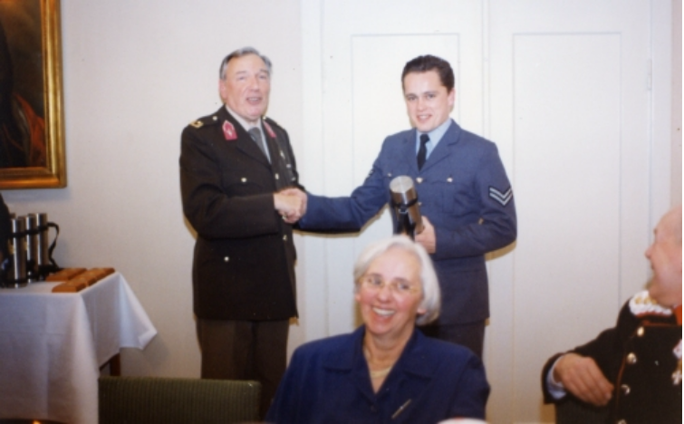

Andy Hammond – NATO Champion ‘96

Brigadier- General Steffers, Andy and I were interviewed on British Forces Broadcasting Service radio, a pre-arranged publicity stunt organised by NATO Godfather Ken Moore! In another NATO ‘first’, a ‘welcome-break’ trip to an outward-bound sports centre involved bewildered chess players in raft-races, archery competitions and assault courses, nation pitted against nation, naturally! Frozen, muddied, soaked through and exhausted, the chess-board seemed a lot less intimidating! The hosts did an excellent job at such short notice, all involved enjoying typically friendly Danish hospitality.
*
The 8th NATO (actually the 20th event) was held in 1997 in the small town of Apt in Provence, Southern France. The organisers overlooked the angle of it being an anniversary milestone, few present aware of the full history of the tournament. The French worked extremely hard within the tried and trusted format to produce a professional event. The beautiful Provence landscapes provided a superb backdrop, though Apt itself was rather quiet. Nine teams competed, including a NATO side, with the Germans always in charge, albeit with on paper a weaker-than-usual team. The hosts seemed to be the favourites, but their top two players didn’t perform. For once, UK put in a solid week’s work and finished 4th, with Hammond, Clifford and Toll all scoring 4.5 / 7. Gerberl (GER) with 6/7 was ‘Le Grand Fromage’, taking Andy’s title. The latter made up for this by winning outright the strong 18-player all-play-all blitz event.
*
The 9th NATO in 1998 was due to be held at Edinburgh University, Scotland in the last week of September. It had all the makings of a classic ‘NATO’. An RAF team touring Scottish chess clubs in January took the opportunity to check it out, marched around the impressive setting by Lt Col Andy Parrott. He was settling into his new job as Commanding Officer of a Scottish Territorial Army Transport Regiment and therefore excellently placed to set the wheels in motion. Sadly, it proved to be no more than a pipe-dream. The University demanded extortionate hotel rates for accommodating their NATO visitors, and all attempts at financing such a costly undertaking ultimately failed. Not a penny was forthcoming from the miserly UK Land Forces - a reminder of what a lowly profile the Sport of Chess currently holds in UK. Just as Euro-eggs were being aimed our way, Her Majesty’s Royal Navy sailed gallantly to the fore, with Messrs. Brokenshire and Geddis baling out the beleaguered Army. Hosted at HMS Nelson in the historic Portsmouth Dockyards, the event attracted teams from 8 NATO countries, with 54 competitors.
An innovative feature was that the event was covered ‘live’ for the first time on tv - daily on Teletext by John Henderson. Additionally, a blitz exchange-chess display in the Dockyards by uniformed players from all countries made it on to the local tv news. A guided tour of the impressive and historic HMS Victory was certainly a memorable highlight. At the board, it was ‘business as usual’ as Germany effortlessly notched yet another win - more interesting was the scrap for 2nd place with Holland sneaking in ahead of France. Young Scots Guardsman Chris Dunlop made his UK debut, but it was the veteran Hammond who was Best Brit on 4.5/7.
*
In 1999, the 10th Official NATO was hosted at Stetten am kalten Markt, a training regiment for Panzer Grenadiers - close to the Swiss border in Southern Germany. Late night blitz games were often disturbed by the shock of exploding shells! On a noticeably smaller budget than in Hammelburg, a fine event was staged.

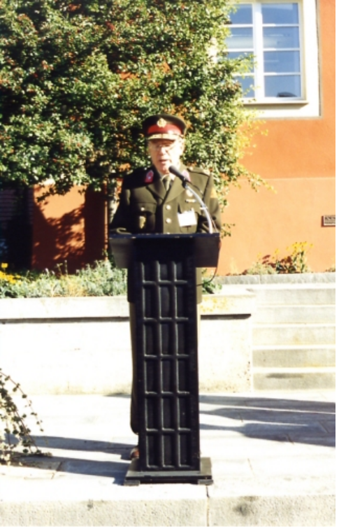

General Steffers opens the Stetten NATO ‘99

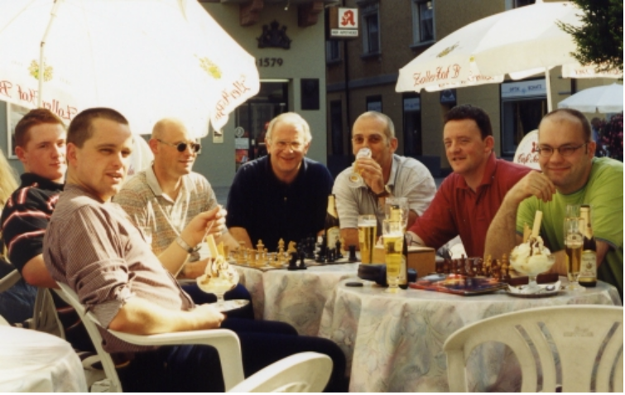
The UK team relax and prepare for a tough week’s chess!

A trip to the source of the Danube in glorious September sunshine was one highlight, another being the entrance of several scantily-clad whooping American Indian dancing girls at the final banquet! 10 teams competed, and in a close finish, the hosts pipped Holland by just one point, Gustafsson (GER) scoring an impressive 6.5/7. Turkey reappeared for the first time since Oslo in 1990.
*
My personal run of attending 18 consecutive NATOs was finally broken in 2000, when I had to serve a 4-month detachment in the Falkland Islands. For the first time, Belgium hosted the 11th NATO event in the Town Hall in Leopoldsburg. 9 teams and 63 players competed, Germany once again taking the team trophy (3.5 points clear of France in 2nd place) and the individual trophy (won by Dottling with 6.5/7). A memorable finale was organised in the form of a Simultaneous Display given by veteran Czech GM Vlastimil Hort. Against strong opposition, Andy Hammond lifted the Blitz Trophy with 8.5/11, restoring some pride to a battered UK team which finished last.
*
Off we all went to San Remo, Italy in 2001 for the 12th NATO, scene of the famous 1930 World Tournament. In fantastic Mediterranean weather, an excellent week’s chess was played at the luxurious Army Recreation Base. A truly memorable competition, 61 players from 10 teams battled for the title. A mid-week break from the chess included a trip to the ‘Museum of the Olive’ in the town of Imperia. In a tortuous, nail-biting finish, the hosts were cruelly robbed of their first NATO win, narrowly pipped by half a point. The crucial encounter between Falbo (ITA) and Helbig (GER) on Board 5 was won by the young German with the black pieces.
*
The 13th NATO took the players to the town of Brest in Northern France. A huge entry of 79 players representing 13 teams, competed. After a 6-year hiatus, the Norwegians returned to good effect, as did the Canadians who last appeared in 1989. For the first time, a team from Poland entered, their strength adding to a tough tournament. Sadly, Wolfgang Berger was a notable absentee, illness preventing him from attending for the first time in the history of the tournament. Played at altitude – atop the ‘Cercle des Officiers Mariniers’, players had a good view of the town whilst competing. After some early setbacks, Germany emerged comfortable winners, but a massive scrap for 2nd place eventually went to the Americans, finally reunited as a Tri-Service team. The four Norwegians managed 3rd – a stupendous effort, as their 4 players all had to score for the team! UK finally had something to cheer about – a finish of 3rd equal, with Hammond joint 1st in the individual event with Helbig (GER on 6/7). Another NATO ‘first’ was the innovation of the top four games in each round going out ‘live’ on the internet, sensory boards relaying the moves to the watching world. An excellent website had been set up by the French, just part of ‘Une Semaine des Echecs’ – a week of chess, which incorporated youth tournaments and a simultaneous display in the town. Local players joined in the ever-enjoyable Blitz event, won handsomely by Phillip Mai (GER).

*

And so to the 14th NATO, to be held near Copenhagen in Denmark. How appropriate that the 25th event should be celebrated in the country where the idea was born. I wish the organisers every success in hosting the Silver Jubilee Tournament and I’m sure it will be a memorable one. Long may this excellent competition continue, fostering as it does lasting friendships and co-operation between member countries, in a week where only the game of chess matters. I can only imagine that the Summer and Winter Olympics evoke the same sentiments.

MOST APPEARANCES (ALL COUNTRIES)

24 - W Berger (GER - National Arbiter)
20 - A J Toll (UK)
15 - B De Cat (BEL)
13 - O G von Ibenfeldt (NOR - FIDE International Arbiter)
12 - J Eggum (NOR - Team Leader), A J Hammond (UK),
O Hjertenes (NOR), N A McInnes (UK)
11 - K Moore (UK/DEN - Tournament Organiser),
G W Sage (UK), E Tommassini (ITA)
10 - F Benedetti (ITA), R W Kermeen (UK),
G J Ludden (NL), S Moen (NOR),
H Steffers (NL), M de Waard (NL)
9 - F Baudin (FRA), A F Brameld (UK), F Charles (Bel)
8 - F Stuhr (DEN), S Wolk (GER)
7 - G Delforge (BEL), R Donati (ITA), G Maxia (ITA),
D Malchair (BEL), P R Watson (UK)
(and many, many other wonderful chess friends!)

TITLED COMPETITORS (1978 - 2002)

Belgium:-
FM G Deleyn 1989, 1990, 1994, 1999, 2000, 2001.

France:-
IM J R Koch 1994. FM P Kesmaecker 1997 - 1998.

Germany:-
FM D Doncevic 1984. FM Dr H J Cordes 1985, 1986. FM B Schneider 1985.
IM W Schon 1988. FM W Schmidt 1988. FM A Zude (also IGM in ‘problem solving’).
IM P Schlosser 1989. FM M Michaelsen 1989. FM M Werner 1989.
FM M Mischustov 1990. FM K Muller 1990. IM F Lipinsky 1999. FM F Dottling 2000.

Holland:-
FM H Jonkman 1995.

Italy:-
FM F Benedetti 1989 - 1992. IM E Arlandi 1992. FM R Ianniello 1999.
FM M Corvi 2000, 2001. FM P Bontempi 2001.

Norway:-
IGM S Agdestein 1986, 1987. FM N Grotnes 1992 - 1995.

United Kingdom:-
IM L Cooper 2001, 2002.

USA:-
FM E Tate 1982, 1983, 1985, 1987 - 1989.

(Many of the above have gone on to earn even higher titles since!)

NATO TOURNAMENTS 1978-1998

COUNTRIES, APPEARANCES AND SQUAD SIZES

YEAR | 78 | 79 | 80 | 81 | 82 | 83 | 84 | 85 | 86 | 87 | 88 | 89 | 90
UNITED KINGDOM | 12 | 8 | 7 | 7 | 12 | 9 | 7 | 10 | 8 | 9 | 9 | 9 | 9
GERMANY | 10 | 10 | 13 | 13 | 6 | 9 | 10 | 7 | 9 | 9 | 10 | 10 | 8
UNITED STATES | 7 | 4 | 7 | 10 | 11 | 6 | - | 8 | 8 | 9 | 8 | 9 | 9
NORWAY | - | - | - | 6 | 8 | 12 | 9 | 10 | 8 | 11 | 9 | 10 | 10
BELGIUM | - | - | - | - | - | - | - | - | 4 | 8 | 10 | 10 | 9
HOLLAND | - | - | - | - | - | - | - | - | - | - | - | 9 | 9
DENMARK | 10 | 7 | 6 | 7 | 6 | 3 | 2 | 2 | - | 2 | 2 | 1 | -
FRANCE | - | - | - | - | - | - | - | - | - | - | - | 10 | -
ITALY | - | - | - | - | - | - | - | - | - | - | - | 9 | 10
TURKEY | - | - | - | - | - | - | - | - | - | - | - | - | 6
CANADA | - | - | - | 2 | 3 | - | - | - | - | 6 | - | 1 | -
POLAND | - | - | - | - | - | - | - | - | - | - | - | -
LUXEMBOURG | - | - | - | - | - | - | - | - | - | - | - | 1 | 1
TOTALS | 39 | 29 | 33 | 45 | 46 | 39 | 28 | 37 | 37 | 54 | 48 | 79 | 71

YEAR | 91 | 92 | 93 | 94 | 95 | 96 | 97 | 98 | 99 | 00 | 01 | 02 | TOT
UNITED KINGDOM | 11 | 10 | 6 | 10 | 7 | 6 | 7 | 8 | 8 | 7 | 8 | 8 | 212
GERMANY | 9 | 10 | 8 | 9 | 6 | - | 6 | 7 | 7 | 7 | 7 | 7 | 207
UNITED STATES | 9 | 10 | - | 7 | 6 | 6 | 6 | 6 | 7 | 6 | 5 | 6 | 170
NORWAY | 10 | 10 | 8 | 8 | 7 | - | - | - | - | - | - | 4 | 140
BELGIUM | 10 | 10 | 7 | 8 | 6 | 7 | 6 | 6 | 6 | 8 | 7 | 7 | 129
HOLLAND | 9 | 9 | 9 | 9 | 7 | 7 | 7 | 7 | 7 | 8 | 8 | 8 | 113
DENMARK | - | 3 | - | 8 | 7 | 6 | 7 | 7 | 7 | 6 | 5 | 5 | 109
FRANCE | 10 | 8 | - | 5 | 6 | 6 | 6 | 6 | 7 | 7 | 7 | 8 | 86
ITALY | 9 | 5 | - | 6 | - | - | 7 | 7 | 6 | 7 | 7 | 8 | 81
TURKEY | - | - | - | - | - | - | - | - | 4 | 7 | 7 | 7 | 31
CANADA | - | - | - | - | - | - | - | - | - | - | - | 5 | 17
POLAND | - | - | - | - | - | - | - | - | - | - | - | 6 | 6
LUXEMBOURG | - | 1 | - | - | - | - | - | - | - | - | - | - | 3
TOTALS | 77 | 76 | 38 | 70 | 52 | 38 | 52 | 54 | 59 | 63 | 61 | 79 | 1304

